Q1:
Code:
int triageScore(int age, int severity, int hours){
int score = (severity * 10) - age + (hours * 2);
return score;
}

int main(){
int patients[3][3] = {
{10,7,2},
{20,8,1},
{30,6,3}
};

int total = 0;

for(int i=0;i<3;i++){
int score = triageScore(patients[i][0], patients[i][1], patients[i][2]);
printf("Patient %d Score = %d\n", i+1, score);
total += score;
}

printf("Average Score = %.2f", total/3.0);
}
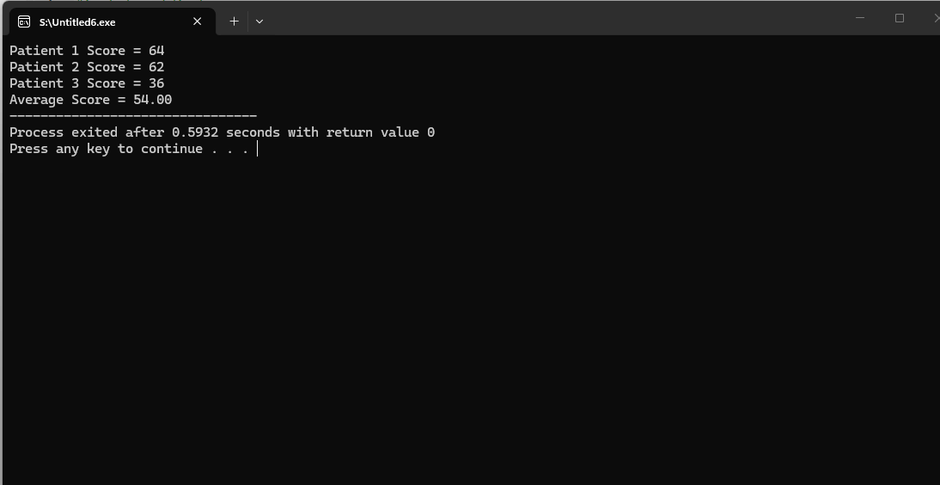

Q2:
Code:
#include <stdio.h>

float applyDiscount(float price, int member){
if(member) return price * 0.8;
else return price * 0.9;
}

float applyTax(float price){
return price * 1.05;
}

int main(){
float price;
int member;

printf("Enter price: ");
scanf("%f", &price);
printf("Are you a member (1=yes, 0=no):? ");
scanf("%d", &member);

float final = applyTax(applyDiscount(price, member));
printf("Final Amount = %.2f\n", final);
}
printInvoice(finalAmount);
}
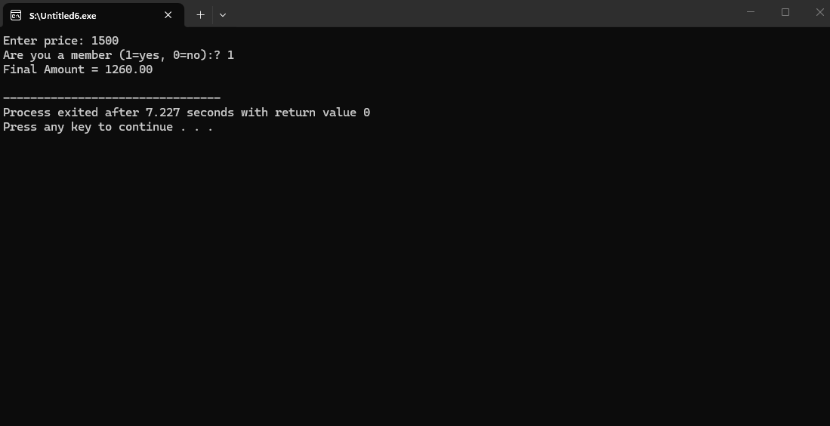

Q3:
Code:
#include <stdio.h>

int totalRuns(int r[]){
int sum=0;
for(int i=0;i<10;i++) sum+=r[i];
return sum;
}

int highest(int r[]){
int max=r[0];
for(int i=1;i<10;i++)
if(r[i]>max) max=r[i];
return max;
}

int above30(int r[]){
int count=0;
for(int i=0;i<10;i++)
if(r[i]>30) count++;
return count;
}

float average(int r[]){
return totalRuns(r)/10.0;
}

int main(){
int runs[10];

for(int i=0;i<10;i++){
printf("Enter runs for match %d: ", i+1);
scanf("%d",&runs[i]);
}

printf("Total = %d\n", totalRuns(runs));
printf("Highest = %d\n", highest(runs));
printf("Above 30 = %d\n", above30(runs));
printf("Average = %.2f\n", average(runs));
}
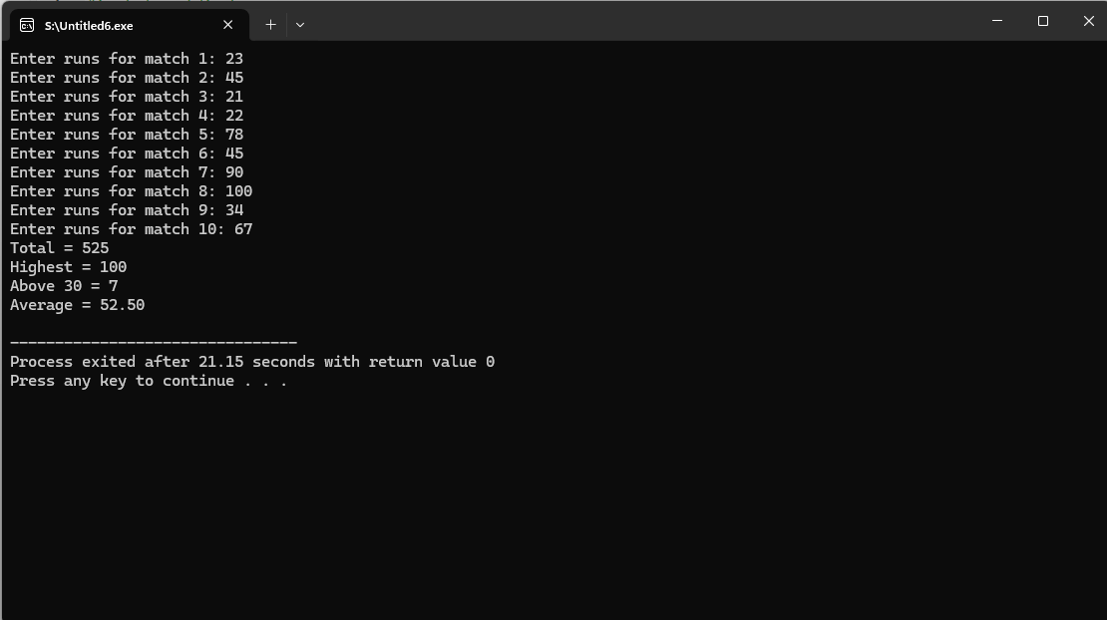

Q4:
Code:

int isValidPIN(int entered, int correct){
return entered == correct;
}

int main(){
int correctPIN = 4729, pin;

for(int i=1;i<=3;i++){
printf("Enter PIN: ");
scanf("%d",&pin);

if(isValidPIN(pin, correctPIN)){
printf("Access Granted\n");
return 0;
} else {
printf("Wrong PIN\n");
}
}
printf("Card Blocked\n");

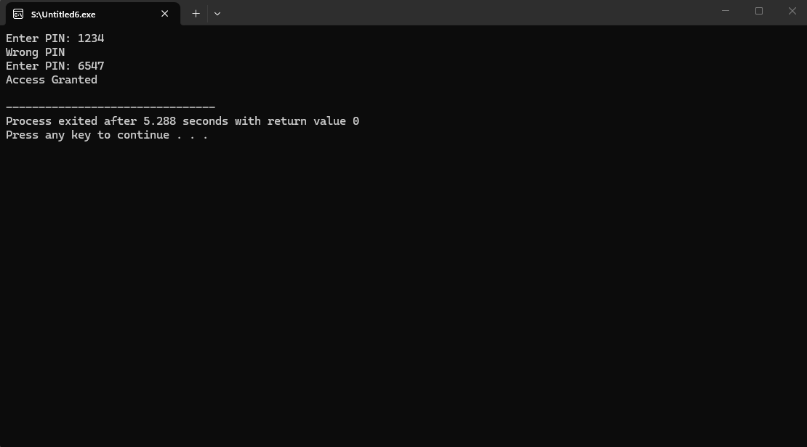
Q5:
Code:
float megajoulesToKiloW(float m){ return m * 1000; }
float kiloWToMilli(float k){ return k * 1000; }

int main(){
float megajoules;

printf("Enter value in Mega: ");
scanf("%f",&megajoules);

float kiloW = megajoulesToKiloW(megajoules);
float milli = kiloWToMilli(kiloW);

printf("Kilo = %.2f\n", kiloW);
printf("Milli = %.2f\n", milli);
}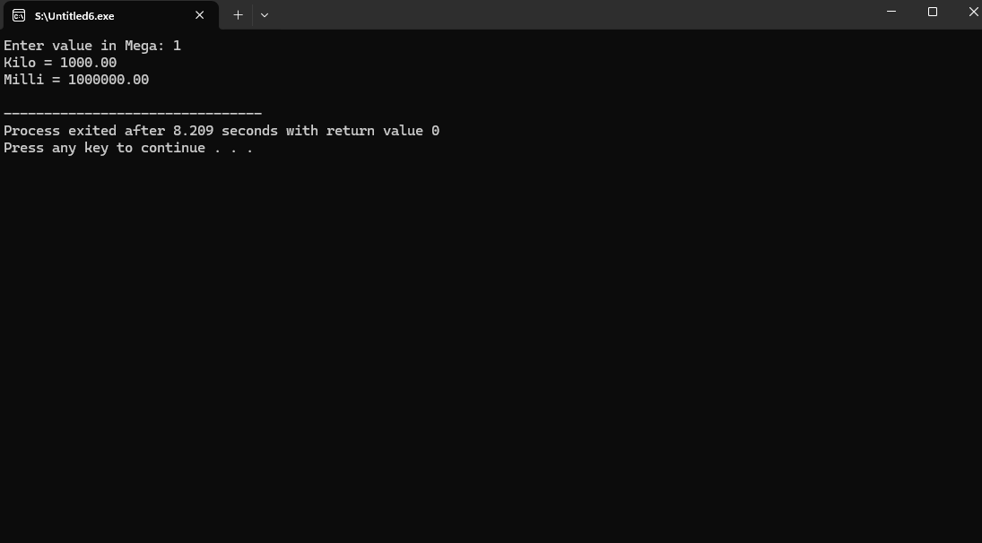

Q6:
Code:
#include <stdio.h>

int total(int b[]){
int sum=0;
for(int i=0;i<5;i++) sum+=b[i];
return sum;
}

int highest(int b[]){
int max=b[0];
for(int i=1;i<5;i++)
if(b[i]>max) max=b[i];
return max;
}

int main(){
int bills[5];

for(int i=0;i<5;i++){
printf("Enter bill %d: ", i+1);
scanf("%d",&bills[i]);
}

printf("Total Revenue = %d\n", total(bills));
printf("Highest Bill = %d\n", highest(bills));
}
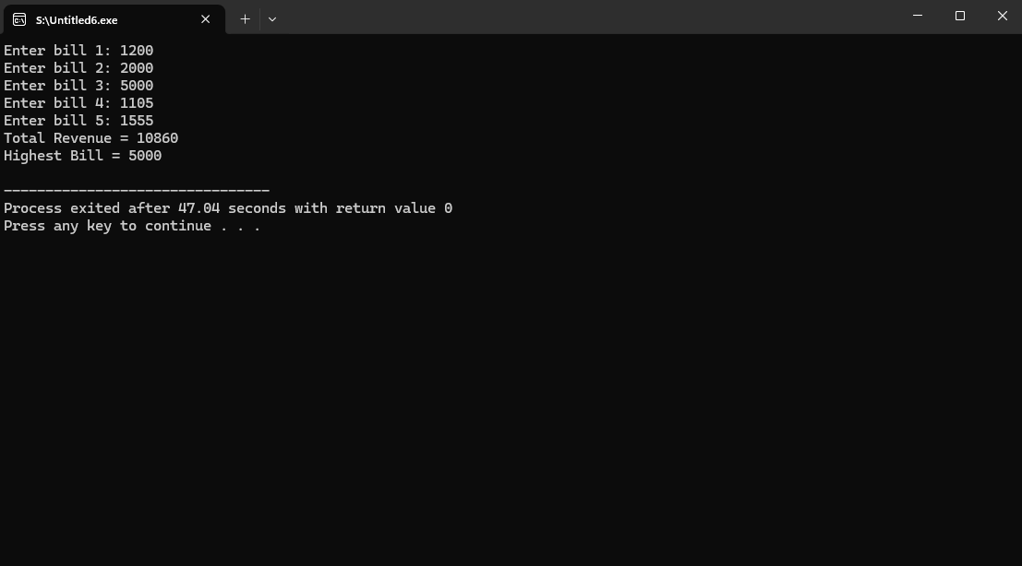

Q7:
#include <stdio.h>

void scale(int m[], int size){
int max=m[0];

for(int i=1;i<size;i++)
if(m[i]>max) max=m[i];

for(int i=0;i<size;i++)
m[i] = (m[i]*100)/max;
}

int main(){
int marks[5];

for(int i=0;i<5;i++){
printf("Enter marks %d: ", i+1);
scanf("%d",&marks[i]);
}

scale(marks,5);

printf("Scaled Marks:\n");
for(int i=0;i<5;i++)
printf("%d ", marks[i]);
}
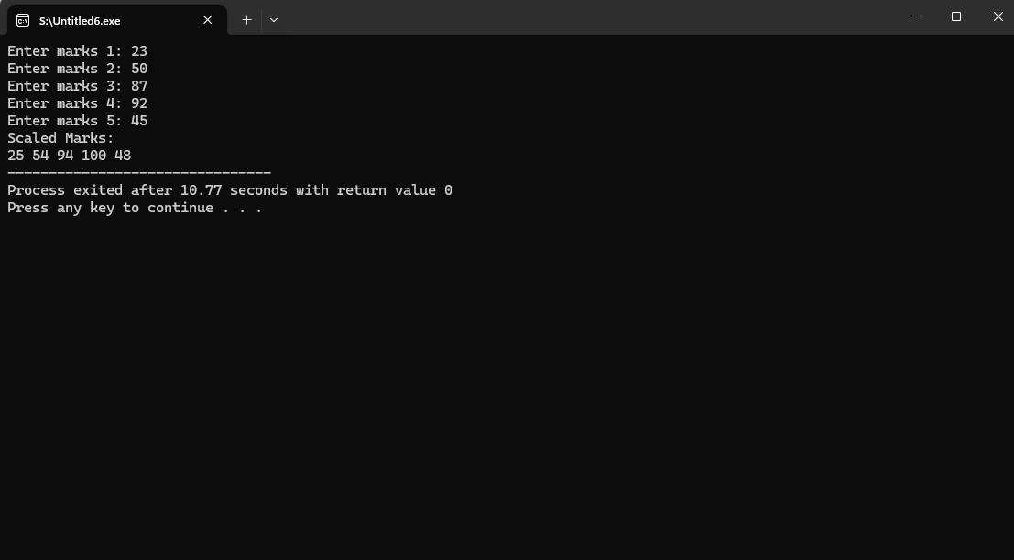

Q8:
Code:

void printData(int vib, float temp, char grade){
printf("Vibration %d\n", vib);
printf("temperature= %.2f\n",temp);
printf("grade=%c \n", grade);
}

int main(){
int vib;
float temp;
char grade;

printf("Enter vibration: ");
scanf("%d",&vib);

printf("Enter temperature: ");
scanf("%f",&temp);

printf("Enter grade: ");
scanf(" %c",&grade);

printData(vib,temp,grade);

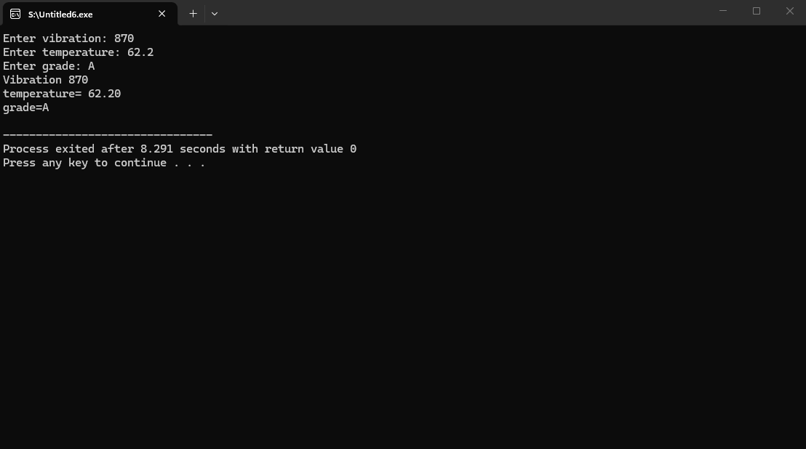

Q9:
Code:
void analyze(int a[4][7]){
for(int i=0;i<3;i++){
int sum=0;
for(int j=0;j<7;j++){
printf("%d ", a[i][j]);
sum+=a[i][j];
}
printf(" student attendance= %d\n", sum);
}
}

int main(){
int att[4][7];

for(int i=0;i<3;i++){
for(int j=0;j<7;j++){
printf("Student %d Day %d: ", i+1, j+1);
scanf("%d",&att[i][j]);
}
}

analyze(att);
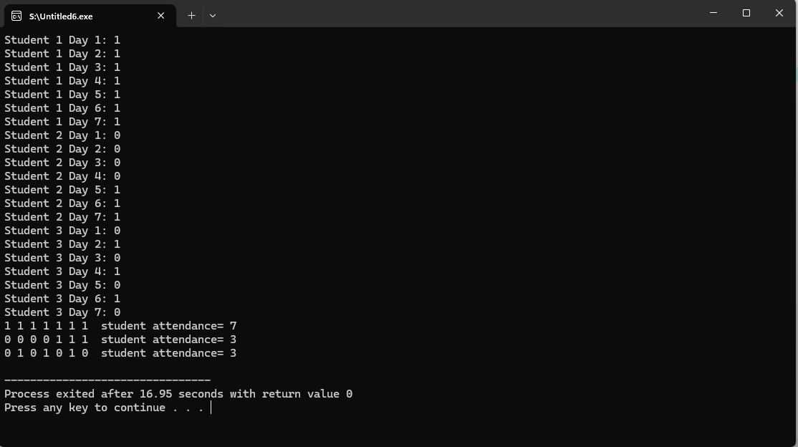

Q10:
Code:
#include <stdio.h>

void basic(int dmg, int hp){
printf("Basic Attack! Enemy HP = %d\n", hp-dmg);
}

void power(int dmg, int hp){
printf("Power Strike! Enemy HP = %d\n", hp-(2*dmg));
}

void heal(int hp){
printf("Heal! HP = %d\n", hp+20);
}

void dispatch(int action, int dmg, int hp){
if(action==1) basic(dmg,hp);
else if(action==2) power(dmg,hp);
else if(action==3) heal(hp);
else printf("Invalid Action\n");
}

int main(){
int action, dmg, hp;

printf("Enter action (1=basic,2=power,3=heal): ");
scanf("%d",&action);

printf("Enter damage: ");
scanf("%d",&dmg);

printf("Enter HP: ");
scanf("%d",&hp);

dispatch(action,dmg,hp);
}
